Perpendicular and Oblique Rays

Chart numbering: The charts are originally numbered as they were in my training, and I’ve also added the corresponding numbering for the “Montessori For Everyone” charts (MFE) when available.

Original impressionistic (hand-drawn) charts: purchase here
Purchase the MFE charts here.

Pre-requisite: Geometry lesson on Perpendicular and Oblique line relationships (find lesson here)

Notes:
- This lesson needs to be given BEFORE you discuss Solstices, Equinoxes, and seasons.
- Because of the slant of the rays, the Earth is heated in different ways and causes different climates in the world. The children might come to this conclusion spontaneously when they are working with the Day and Night lesson, as they see the light falling on the globe. However, this is a new layer in their knowledge.

MATERIALS:
- Ball of clay
- Skewer sticks
- Bar of clay
- Charts (see lesson)
- Magnifying glass
- Tube
- Flashlight
- Solar mask (homemade)

PRESENTATION: Perpendicular and oblique rays

- We said that during the day, there is a time when the Sun is directly above us and the Sun’s rays fall perpendicularly onto the surface of the Earth. Hold a ball of clay and put a stick into it perpendicularly.
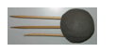
- However, there are areas of the Earth in which this never happens. Put two more sticks in the same direction, one above and one below the first perpendicular stick. Observe with the children how not all of the rays are at a right angle to the sphere.

- Show a bar of clay. If the surface of the Earth were like the bar of clay, then all the rays of the sun would be perpendicular. Take the sticks out of the sphere and stick them on the bar of clay (on the tray). But because the Earth is a sphere, this is not so.

- Where the rays fall perpendicular to the surface of the Earth, it is very hot. Let’s find out why that is.

- Show chart 11a/MFE 9
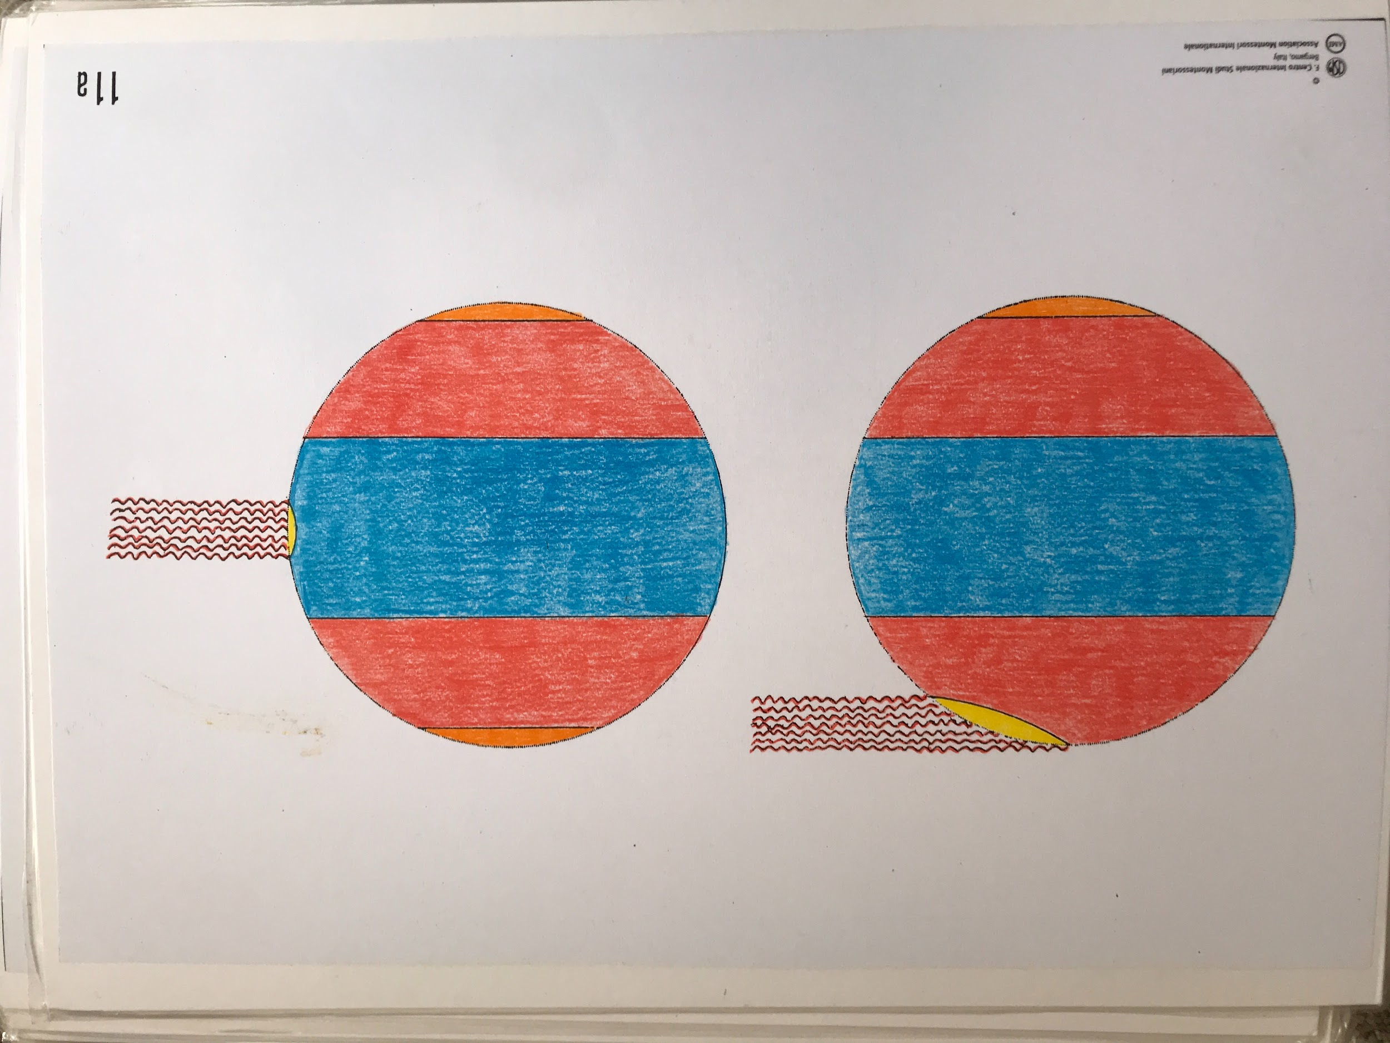

- We have a small area where the sun’s rays fall perpendicularly, and a larger area where the sun’s rays fall obliquely. Count the number of rays that fall perpendicularly and those that fall obliquely. They are the same amount. The same amount of heat, when it falls perpendicularly, is more concentrated and strikes a smaller area. In the second (left) example, the rays that strike the Earth obliquely cover a larger area and the heat is not as concentrated.

- Demonstration: Use a light through a tube (or a flashlight). Point it at the chalkboard perpendicularly and ask the child to trace the circle of light. Then point the light obliquely and ask him to trace the shape again. Try to line up the light so that the two circles have the same base. Point out that no extra light was added. Ask the child what happened: The child will see that when the light fell perpendicularly, the rays heated a smaller area, and when it was oblique the same amount of rays hit a larger area, so it is less warm.

- Show chart 12a/MFE 10
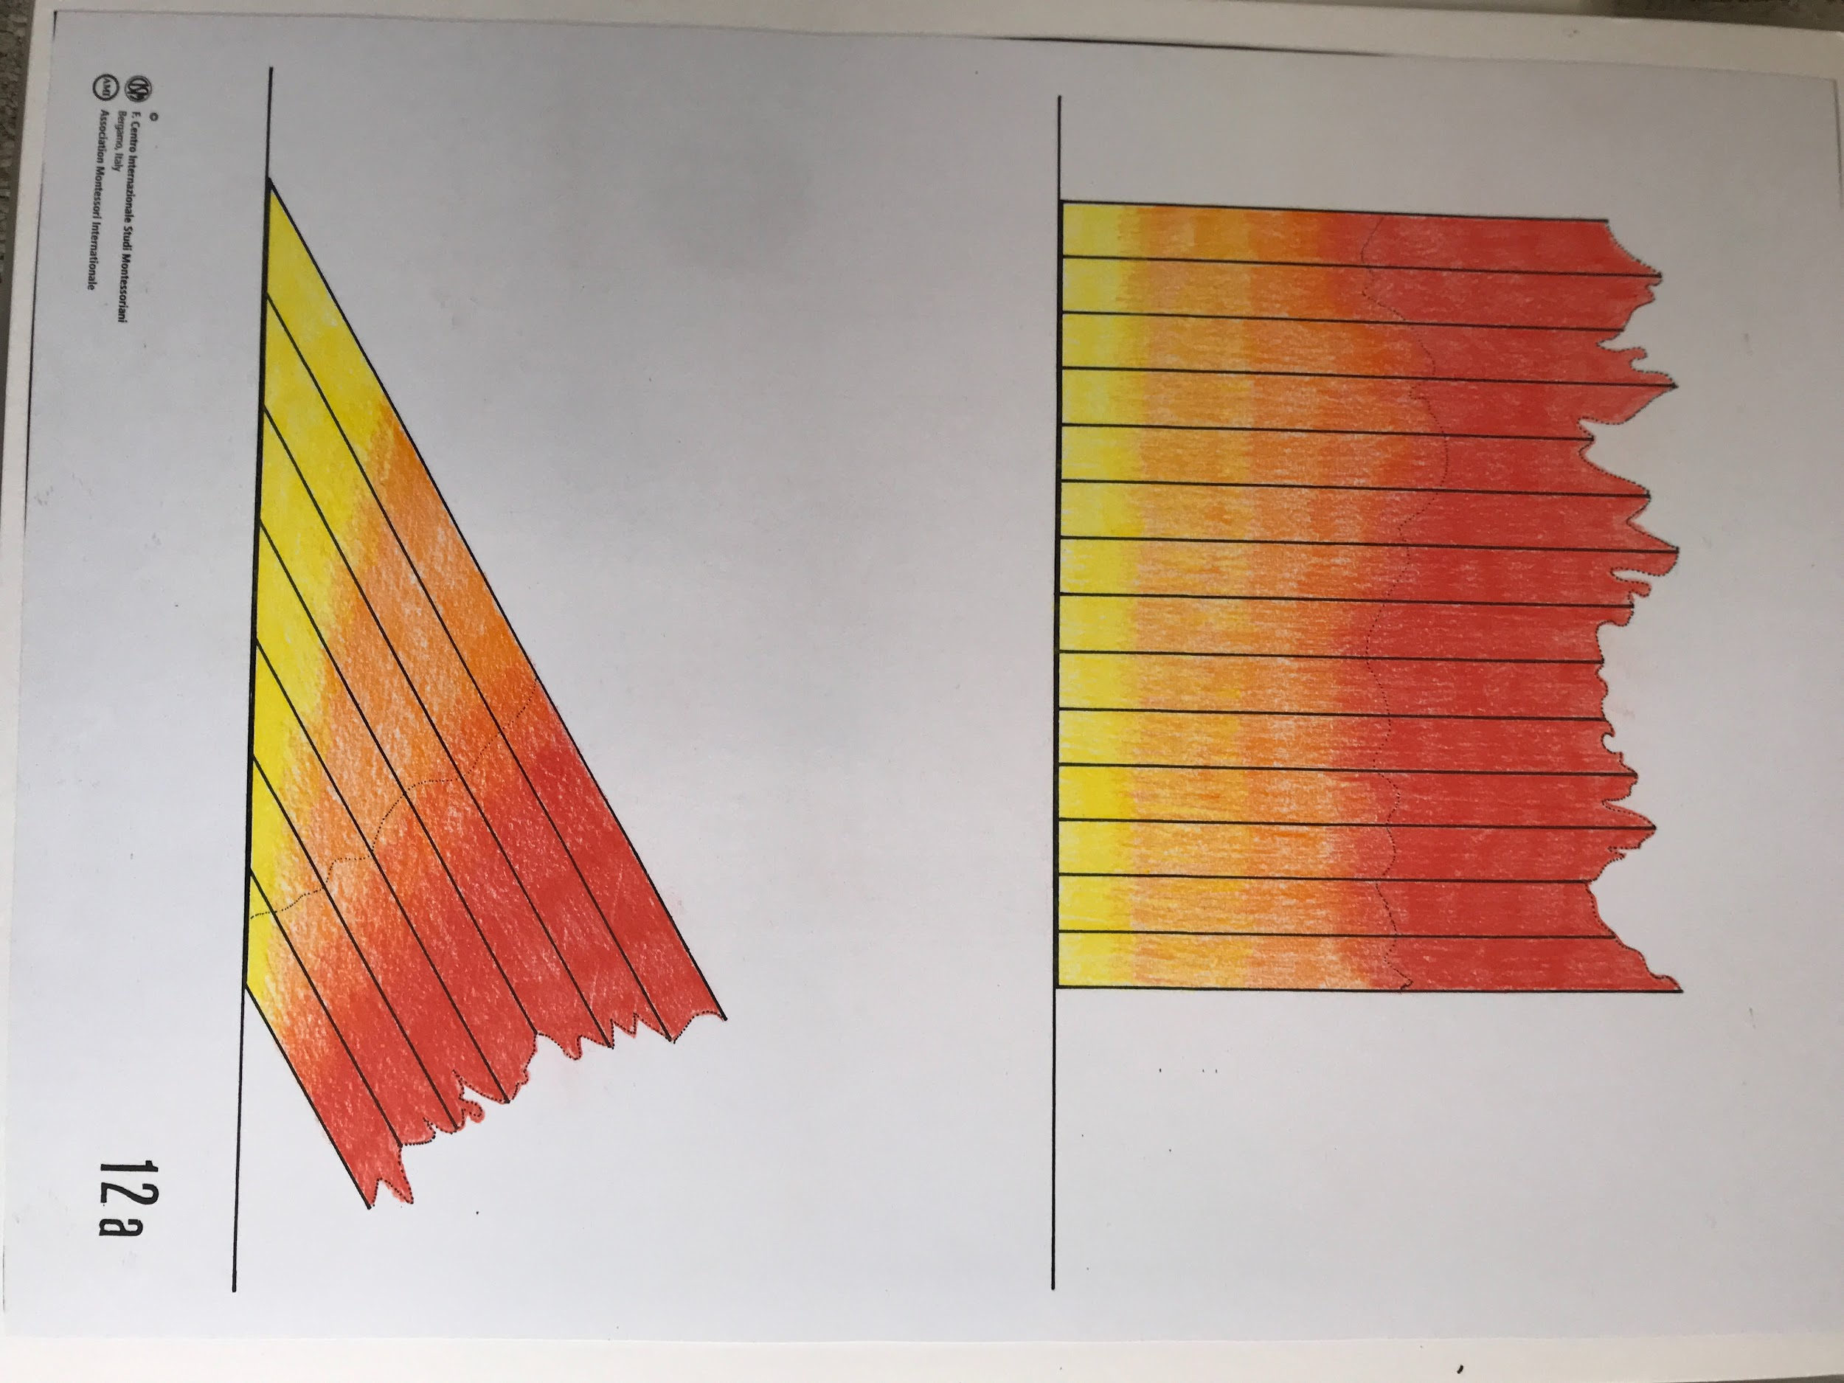

- The top picture shows the rays striking perpendicularly. Count the rays: 14. The bottom picture shows the rays striking obliquely. Count the rays: 7. Make sure that the same area is being hit by the sun: do this by measuring the base that the sun strikes on each picture. It is the same (21 cm.). The area heated with perpendicular rays gets twice the amount of heat as the area heated by oblique rays. Now it’s easier to understand that in some parts of the Earth it’s much hotter than in others.

Follow-up Demonstration: Concentrated heat
On a sunny day, you can do an experiment with a magnifying glass to show how heat can be concentrated in a small area, and refer back to the charts above.

OPTIONAL: The Solar Mask

DIY instructions:
- Cut a piece of yellow construction paper so that its height is equivalent to the diameter of the fraction circles and the base/length is about twice as long as the diameter of the circles.
- With a ruler, mark 0.5cm intervals on both sides of the height, then connect with straight lines.
- Place one edge (height) of the rectangle in line with the diameter of the circle, and trace half the circumference. Cut out so that the “mask” wraps around the circle (like in the picture).
- Lightly color in red and orange the opposite end of the mask (the part not cut in a semicircle). The colors should be more intense on the side opposite the semicircle, and should fade as they get closer to the semicircle (to represent the waning intensity of the heat of the sun).

Solar Mask Demonstration:
- Place the whole of the divided circles on the Solar Mask and point out all the parallel rays coming from the Sun and heating one half of the Earth. Remove the whole and fill with five-tenths the part of the Earth that is hit by the Sun. Count the rays in the outer area, aka one-tenth (4 rays). Then, count the rays that strike the central tenth (16 rays).
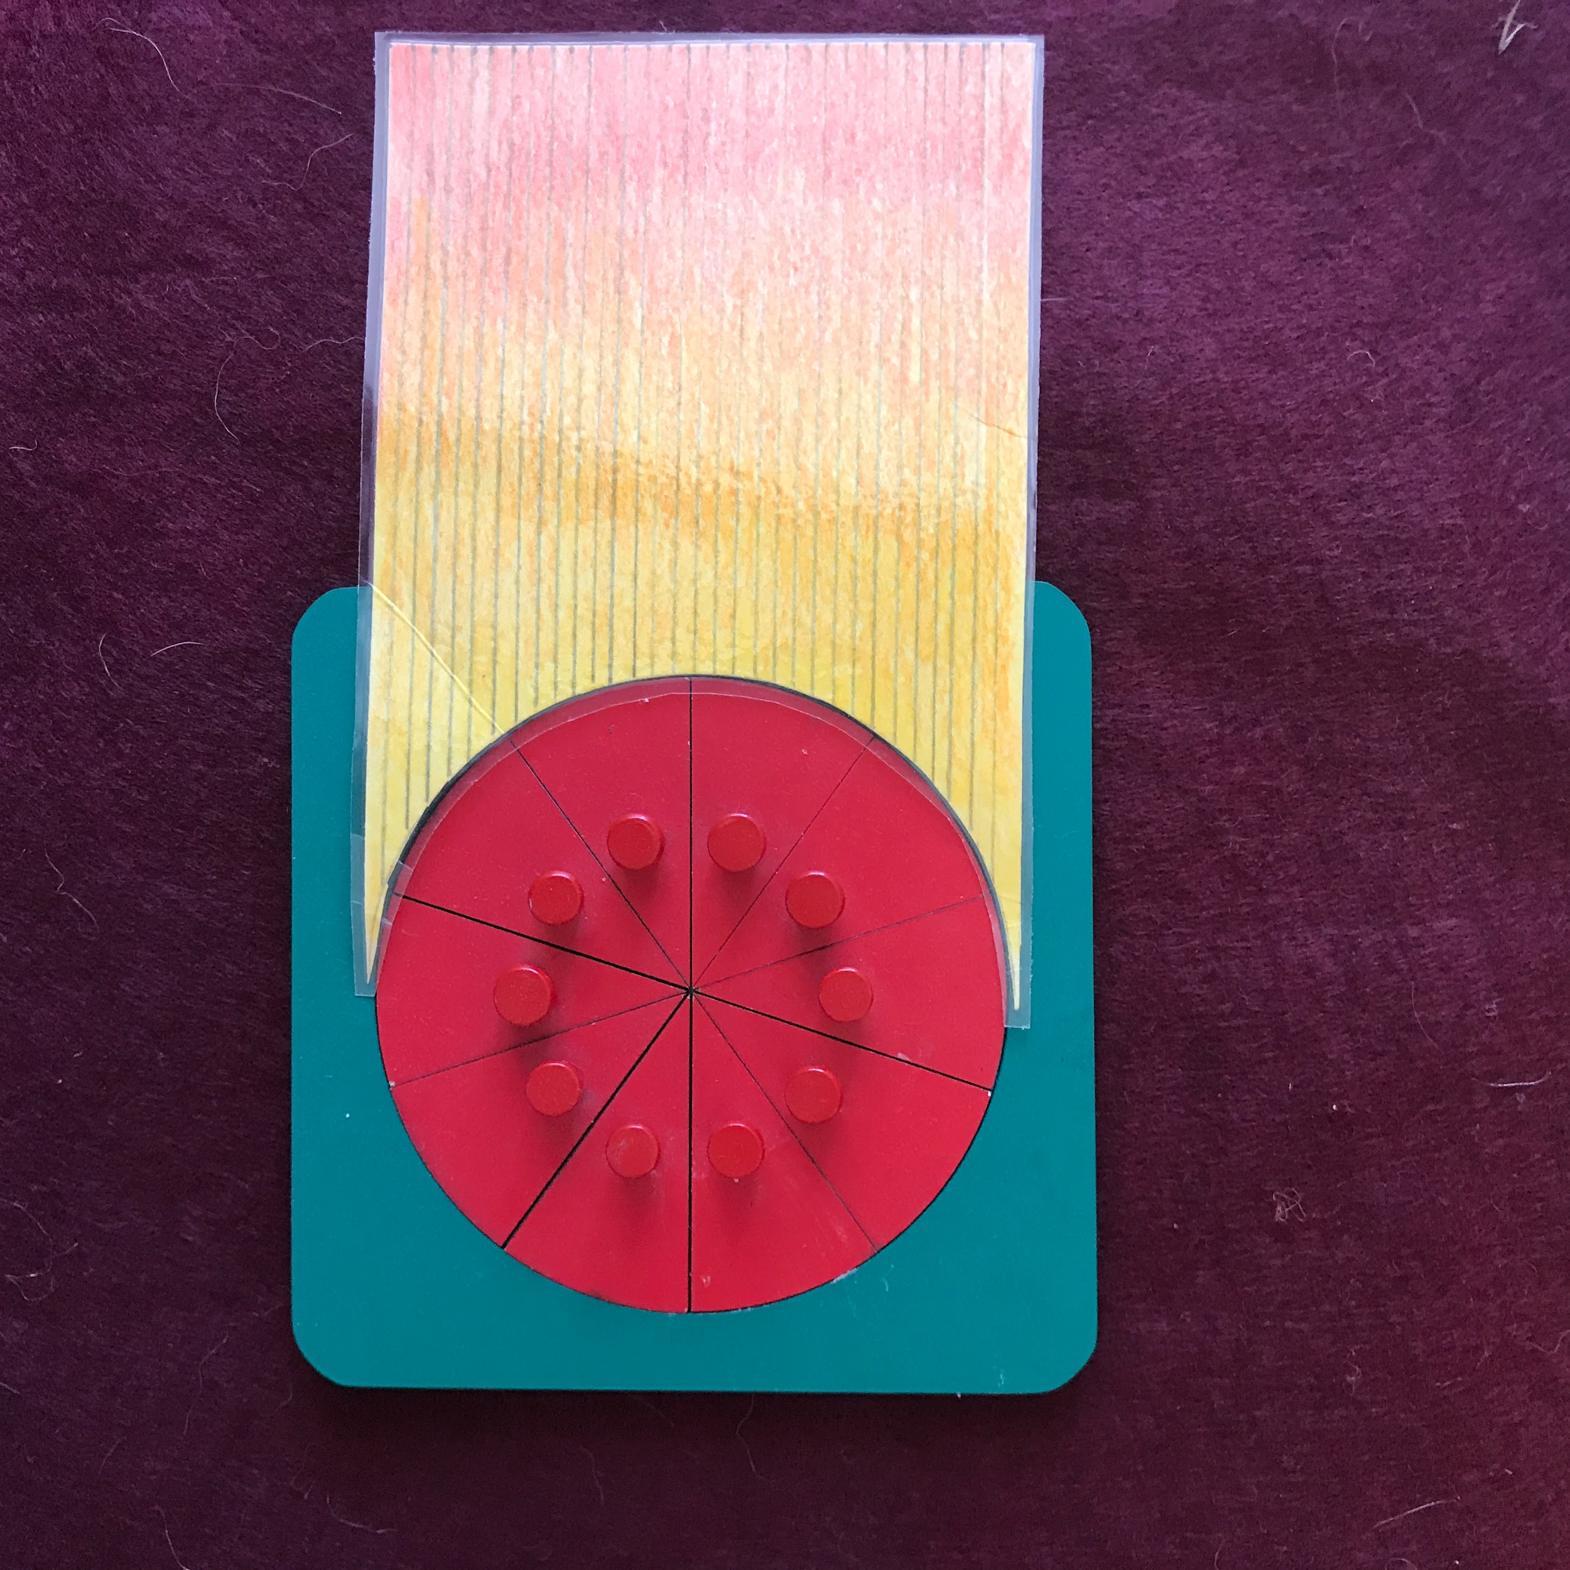

- Show chart 14a/MFE 12
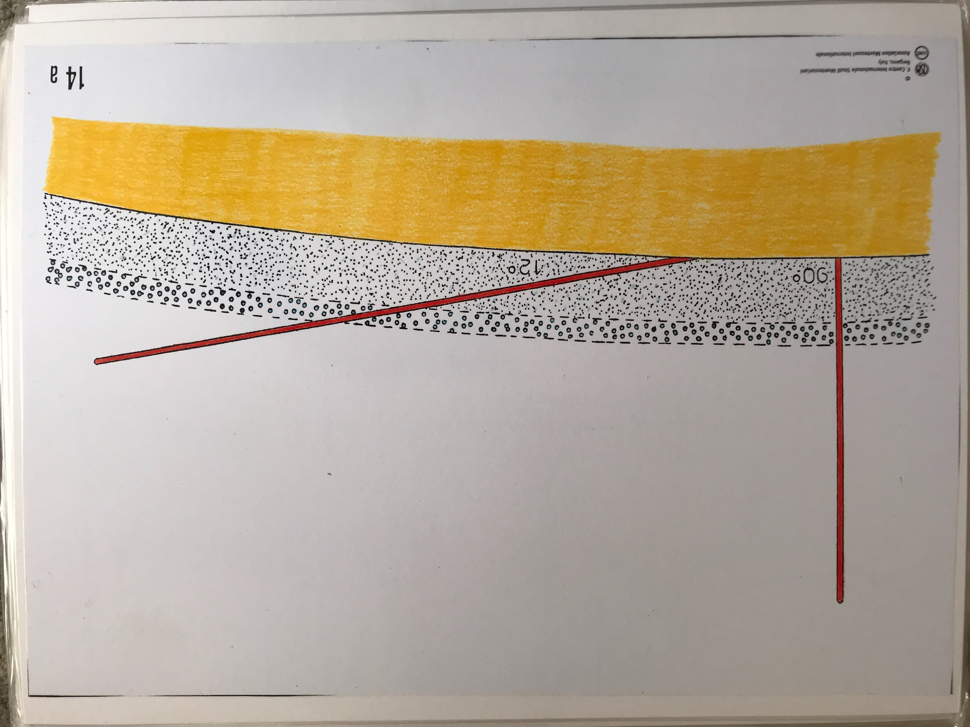

- Tell the children: We can think of these rays as two travelers going through a forest. The perpendicular traveler takes the shortest way straight down. The oblique traveler has to go through a lot more of the forest and will be more tired. In other words, he has to go through more of the atmosphere before he reaches the surface of the Earth. The perpendicular traveler has to go a shorter distance; the oblique one has to go a longer distance. The oblique ray loses a lot of heat to dust and particles in the atmosphere, whereas the perpendicular ray has a shorter distance to travel and thus retains a lot of its heat.

